**Singaporeans doubled down on keeping healthy amid COVID-19 with**

**3 in 4 making improvements in their health as a result**

*Takeaways from the AIA Real Rewards Poll 2020 highlight the value of an all-rounded approach to health, and provides insights on opportunities to further support Singaporeans on their health journey*

**SINGAPORE, 27 August 2020** – AIA Singapore today announced findings from the AIA Real Rewards Poll 2020 which revealed that:

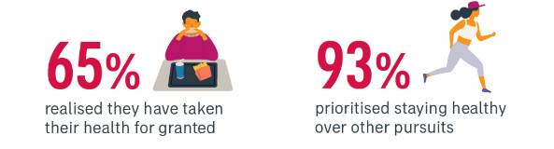

* As a result of COVID-19, two-thirds (65%) of Singaporeans realise that they have been taking their health for granted,
* With more than 7 in 10 (72%) defining the true value of good health as living healthier, longer, better lives with their families and loved ones in today’s socially distant world, and

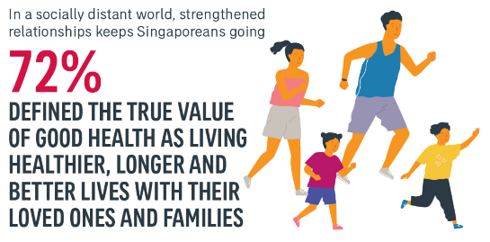

* A whopping 93% prioritised staying healthy over other pursuits to get through the circuit breaker period.
* As a result, a significant three quarters of respondents (75%) recorded an improvement in at least one aspect of their well-being – whether in terms of improved eating habits, physical health, sleeping pattern, or mental health – within 8 weeks from the start of the Circuit Breaker in early April 2020.

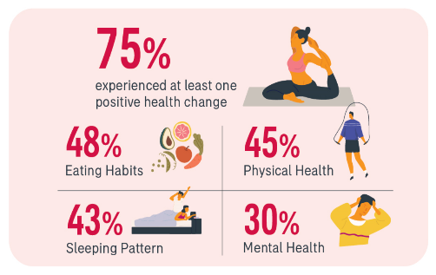

The study was conducted amongst 875 participants in mid-June 2020 as Singapore moved into phase two of safe reopening.

“It is encouraging that, in these trying times, Singaporeans have taken steps to make positive changes to their health, and they are already reaping the rewards of these simple actions. Our aim is to support even more Singaporeans to achieve their health goals, building on this momentum to enable them to truly live healthier, longer, better lives.

We know that it is not enough to only take care of our physical health. This is why, as a leading insurer in the health space, we take a holistic approach to protecting our customers’ wellbeing across financial, physical, and mental health,” said Ms Melita Teo, Chief Customer and Digital Officer, AIA Singapore.

The AIA Real Rewards Poll 2020, combined with an analysis of AIA Vitality members’ health, provided three note-worthy insights for Singapore.

**#1: Singaporeans are adapting by looking beyond keeping active to stay healthy: A well-rounded approach to health includes eating well and getting adequate sleep**

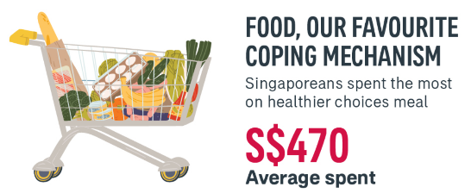

Singaporeans did not compromise on eating right as they continue to spend approximately S$470 a month personally on healthy food, even as they reduced overall living expenses amid the pandemic. Instead, they got healthier and saved money by cutting down expenses on junk food and alcohol.

* Overall, Singaporeans were placing a high priority on making healthier choices, allocating the highest portion of the living expenses (34%) on healthier meal choices.

Aside from nutrition, Singaporeans are also adapting by paying off their sleep debt. Adults are recommended to get approximately 7 – 9 hours of sleep daily[1].

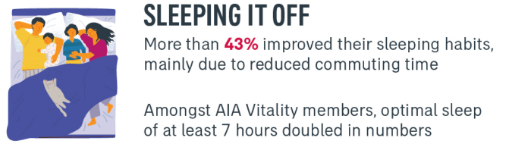

* More than 2 in 5 (43%) of Singaporeans have improved their sleeping habits in this period, pointing to reduced commuting time as the key reason why.
* This is also reflected in sleep patterns of AIA Vitality members: There were twice as many qualifying sleeps tracked on the wellness programme – of at least 7 hours daily – during the Circuit Breaker compared to the preceding months.

The need to address sleep deprivation is especially critical in Singapore, which ranks as the third most sleep-deprived city in the world.[2] AIA launched the #OneMoreHour initiative last year, encouraging people to get an additional hour of sleep, with a [content hub](https://www.aia.com/en/healthy-living/onemorehour.html) created to help improve their sleeping habits.

This follows from a 2019 study AIA conducted which found that 56% of Singaporeans get six or lesser hours of sleep each night and more than half worry about not getting adequate sleep or want to get more. 3 in 5 (59%) agreeing that getting one more hour of sleep would boost their mood and energy.[3]

In addition to the multiple negative impact on health, sleep loss comes at an economic cost too. Developed economies are estimated to be losing 2 – 3 % of their annual Gross Domestic Product (GDP) as a result of insufficient sleep.[4]

**#2: Keeping healthy helps Singaporeans better manage their mental health: More needs to be done to ensure Singapore’s mental well-being**

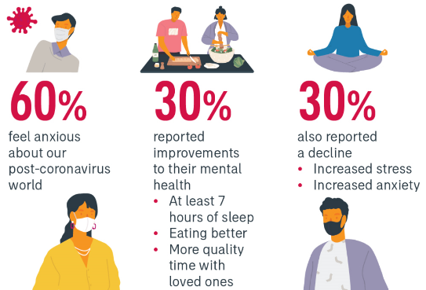Unsurprisingly, approximately 3 in 5 (60%) of Singaporeans are anxious about our post-coronavirus world.

Keeping healthy has helped many manage their stress and anxiety:

* Approximately 1 in 3 (30%) Singaporeans reported improvements to their mental health during COVID-19 – aided by simple steps such as getting at least seven hours of sleep, eating more nutritious meals, and spending quality time with loved ones.
* Multiple aspects of keeping healthy contribute to improved mental well-being[5].

However, a similar number of Singaporeans also reported a decline in their mental health due to increased stress and anxiety (30%). This echoes a worrying trend seen elsewhere in Singapore as a result of the pandemic. The National Care Hotline, set up in April 2020 to provide additional support for people facing mental health challenges, received more than 6,600 calls by the end of the same month with approximately 1,000 people identified as requiring even more targeted support thereafter[6].

**#3: Singapore continues to be the most active in Asia, even amid COVID-19: Nurturing a stronger healthy-living culture a joint responsibility of the public and private sector**

Compared to their counterparts across the region, AIA Vitality members in Singapore were the most active group:

* Despite the pandemic, members in Singapore recorded the highest percentage of workouts tracked on the programme between January to May 2020 amongst 12 markets across Asia-Pacific.
* Even before COVID-19, AIA Vitality members in Singapore have consistently been amongst the most active. For members who are active on the programme’s Weekly Fitness Challenge, more than half typically exceed the minimum weekly target.

“The success of our nation’s initiatives to encourage healthy living is evident in the continued high levels of activity amongst Singaporeans despite the Circuit Breaker measures, with many finding creative ways to continue keeping fit while working from home. This is encouraging, and speaks to the immense opportunity we, the private sector, have to continue nurturing a healthy-living culture in Singapore and improving the health of our population,” shared Ms Teo.

With more than 100,000 members in Singapore alone, AIA Vitality was the first wellness programme introduced by an insurer locally in 2013 and has since yielded significant health results:

* Strong clinical outcomes[7] for members including improvements in glucose levels, blood pressure, cholestrol levels and BMI.

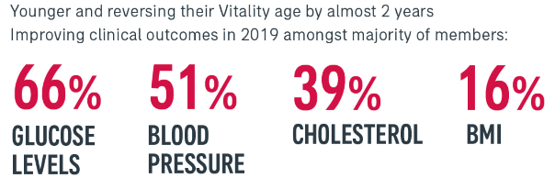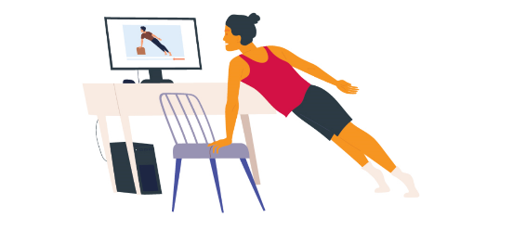

* The impact of AIA Vitality has been most salient amongst members who were initially reported to be in the unhealthy age. On average, they have gotten “younger”, reversing their Vitality Age by approximately 2 years since joining the programme. The difference between members' Vitality Age compared to their biological age has since shrunk by half. Vitality Age is a measure of how healthy an individual is relative to their actual age.

Designed by medical experts, AIA Vitality stands out for its well-rounded approach to health. The programme is constantly being evolved to help members better understand and improve their own health. These ongoing enhancements are developed based on insights gleaned from data on members’ health improvements, continued research, and behavioural science, amongst others.

To help individuals and families in Singapore embrace new norms of reaching their health goals at home, AIA hosted AIA Live on 2 August 2020, an online event where AIA Global Ambassador David Beckham, award-winning chef Jeremy Pang and celebrities from across Asia Pacific came together to explore how to achieve healthier, longer, better lives together. Local celebrities Andie Chen, Andrew Marko, and Amanda Chaang were part of the exciting line-up for the day. AIA Live covered multiple aspects of health and wellness including sessions on fitness, meditation, making healthier meals, body positivity, and more. A recording of the full AIA Live programme is available for viewing here: <https://bit.ly/AIALive2020SG>

- END -

**About AIA**

AIA Group Limited and its subsidiaries (collectively “AIA” or the “Group”) comprise the largest independent publicly listed pan-Asian life insurance group. It has a presence in 18 markets in Asia-Pacific – wholly-owned branches and subsidiaries in Mainland China, Hong Kong SAR[8], Thailand, Singapore, Malaysia, Australia, Cambodia, Indonesia, Myanmar, the Philippines, South Korea, Taiwan (China), Vietnam, Brunei, Macau SAR[9], New Zealand, a 99 per cent subsidiary in Sri Lanka, and a 49 per cent joint venture in India.

The business that is now AIA was first established in Shanghai more than a century ago in 1919. It is a market leader in the Asia-Pacific region (ex-Japan) based on life insurance premiums and holds leading positions across the majority of its markets. It had total assets of US$291 billion as of 30 June 2020.

AIA meets the long-term savings and protection needs of individuals by offering a range of products and services including life insurance, accident and health insurance and savings plans. The Group also provides employee benefits, credit life and pension services to corporate clients. Through an extensive network of agents, partners and employees across Asia-Pacific, AIA serves the holders of more than 36 million individual policies and over 16 million participating members of group insurance schemes.

AIA Group Limited is listed on the Main Board of The Stock Exchange of Hong Kong Limited under the stock code “1299” with American Depositary Receipts (Level 1) traded on the over-the-counter market (ticker symbol: “AAGIY”).

Contact:

Allison Chew

[Allison-A.Chew@aia.com](mailto:Allison-A.Chew@aia.com)

Dawn Teo

[Dawn-my.teo@aia.com](mailto:Dawn-my.teo@aia.com)

1. *‘How Much Sleep Do We Really Need?’ (2020) SleepFoundation.org. Information available at:* [*https://www.sleepfoundation.org/articles/how-much-sleep-do-we-really-need*](https://www.sleepfoundation.org/articles/how-much-sleep-do-we-really-need)
2. *‘How does Sleep Deprivation affect You?’ (2020) HealthHub.sg. Information available at:* [*https://www.healthhub.sg/live-healthy/1034/sleep-deprivation#:~:text=Singaporeans%20are%20amongst%20the%20most,sleeping%20well%20is%20not%20okay.*](https://www.healthhub.sg/live-healthy/1034/sleep-deprivation#:~:text=Singaporeans%20are%20amongst%20the%20most,sleeping%20well%20is%20not%20okay.)
3. *‘Get #OneMoreHouse of sleep for a healthier, longer, better life’ (2019) AIA. Information available at:* [*https://www.aia.com.sg/en/onemorehour.html*](https://www.aia.com.sg/en/onemorehour.html)
4. *‘Investing in sleep for health and wellbeing dividends. A view from one of Asia’s leading sleep scientists.’ (2019). Dr Michael Chee, Professor, Duke-NUS Medical School and Principle of the Cognitive Neuroscience Lab. Member of AIA’s Healthier, Longer, Better Lives Advisory Board. Information available at:* [*https://www.aia.com/en/healthy-living/onemorehour/professorchee.html*](https://www.aia.com/en/healthy-living/onemorehour/professorchee.html)
5. *10 Essential Tips for Mental Well-Being’ (2020) HealthHub. Information available at:* [*https://www.healthhub.sg/live-healthy/1926/10-Essentials-for-Mental-Well-Being*](https://www.healthhub.sg/live-healthy/1926/10-Essentials-for-Mental-Well-Being)
6. *‘Mental health fallout: How COVID-19 has affected those in Singapore. (9 May 2020) The Straits Times. Janice Tai. Social Affairs Correspondent. Information available at:* [*https://www.straitstimes.com/singapore/health/mental-health-fallout*](https://www.straitstimes.com/singapore/health/mental-health-fallout)
7. *Metrics improvements tabulated based on members’ first submission and latest submission of their health screening results.* 
8. *Hong Kong SAR refers to Hong Kong Special Administrative Region.*
9. *Macau SAR refers to Macau Special Administrative Region.*